**Experiment 2.3**

**Competitive Coding Lab 7(String)**

**Student Name: Sahul Kr. Parida UID: 20BCS4919**

**Branch: CSE Section/Group: WM-904/B**

**Semester: 5th Date of Performance: 27/10/22**

**Subject Name: Competitive Coding(CC) Subject Code: 20CSP-314**

**PROBLEM STATEMENT 7.1: -**

<https://www.hackerrank.com/challenges/separate-the-numbers/problem?isFullScreen=true>

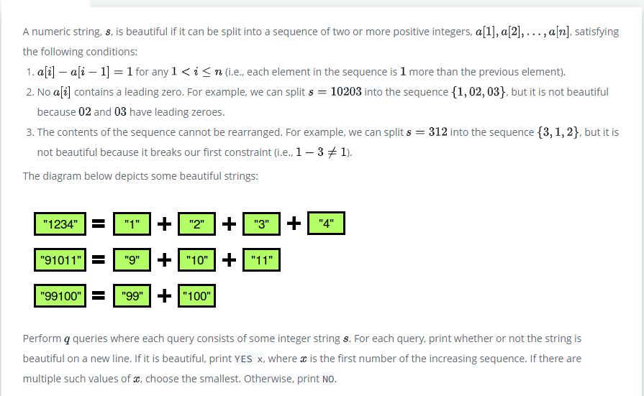

**SOLUTION:**

static long solve(String s)

{

        if (s.charAt(0) == '0') {

            return -1;

        }

        for (int length = 1; length * 2 <= s.length(); length++) {

            long firstNumber = Long.parseLong(s.substring(0, length));

            StringBuilder sequence = new StringBuilder();

            long number = firstNumber;

            while (sequence.length() < s.length()) {

                sequence.append(number);

                number++;

            }

            if (sequence.toString().equals(s)) {

                return firstNumber;

            }

        }

        return -1;

    }

# TEST CASES:

# 

**PROBLEM STATEMENT 7.2: -**

<https://www.hackerrank.com/challenges/pangrams/problem?isFullScreen=true>

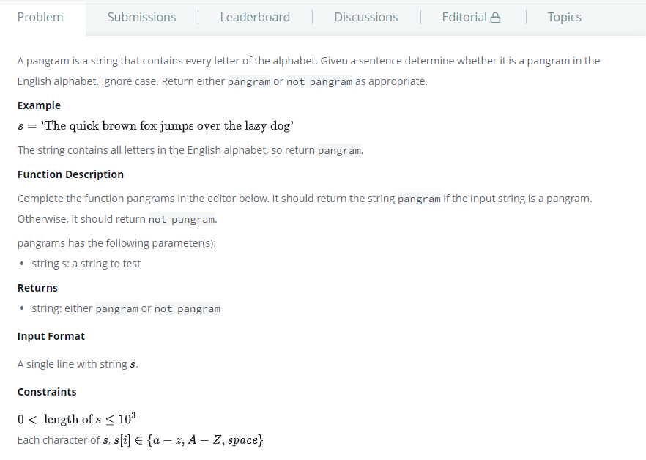

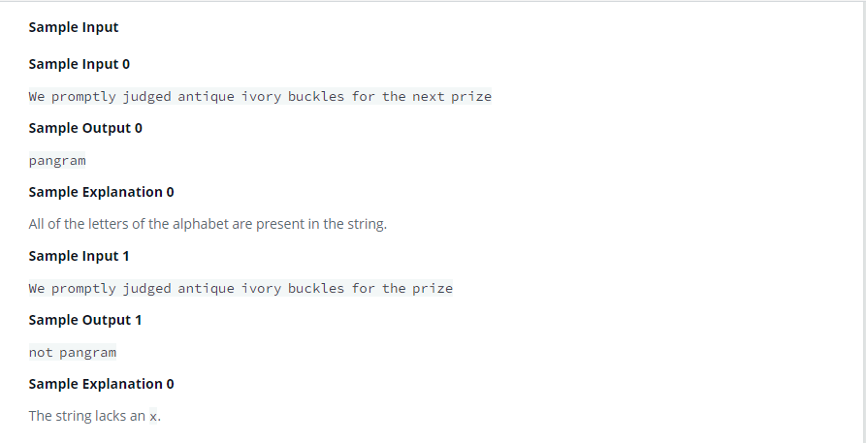

**SOLUTION:**

    string pangrams(string s)

{

    int arr[26] = {0};

    for(char& c : s)

    {

       if(c >= 97 && c <= 122)

       {

           arr[c - 97] = 1;

       }

       else if(c >= 65 && c <= 90)

       {

            arr[c - 65] = 1;

       }

    }

    for(int i = 0; i < 26; i++)

        if(arr[i]==0)

          return "not pangram";

    return "pangram";

    }

# TEST CASES:

# 